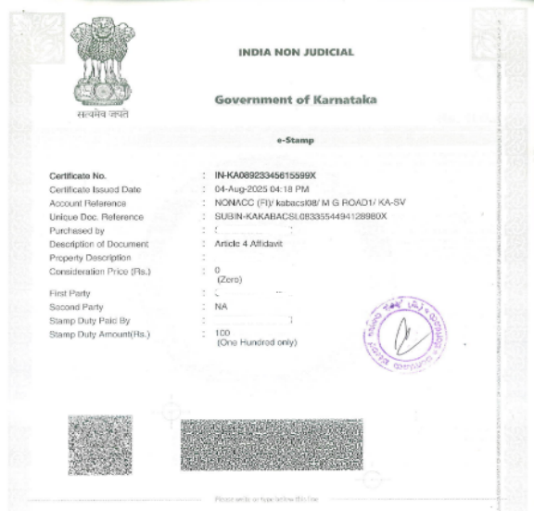**STATUTORY DECLARATION**

I <Name of the Declarer> s/o <Current Residential Address of the Declarer> and presently working with <current employment details of the declarer> makes the following declaration:

Mr. <Applicant’s Full name> was working at <Company Name> from 15th October 2018 to 31st December 2019. He is a full-time employee working 40hrs/week at the Mumbai location.

During this time, I was his colleague and I was working with <Company Name>, from 8.10.2018 to 31.03.2020 as a full time permanent employee in the same organization as Manager-Technical Operations. I understand that Mr. <Applicant’s Full name> could not get a detailed reference letter as the company does not provide the reference letters in the requested format. <Reason>

I can confirm that <Applicant’s Full name> carried out the duties and roles specified in this document at <Company Name>, as I am his Supervisor/Manager who interacts with and witnesses his work on a regular basis throughout his employment.

**The following are the details of the above-mentioned organization:** <Company Name and Address>

**The details of <Declarer’s Full Name> are as follows:**

Contact Person :

Position at time of leaving:

Tenure:

Contact Number:

Email address : <Personal email address>

**The details of** <Applicant’s Full name> **are as follows:**

Position at time of leaving:

Tenure :

Type of job: full time, permanent

Hours/Week: 40 hours per week

Salary Earned:

Contact Number:

Email address:

During his tenure in the company, his main Roles and Responsibilities were as follows: Role: Lead Operations

● ’

●

●

●

●

●

●

I believe and declare that the above contents are true to the best of my knowledge, I understand that person who intentionally makes false statements in statutory declaration is guilty of an offence, and I believe that the statements in the declaration are true in every particular.

Sworn Before

Date :

Place: Bengaluru, Karnataka, India

